Sprint Review Report
Sprint: 2 Date: Thursday 20//11/2025
Product: Event Hub Application
Sprint Goal: Improve the overall user experience by enhancing event management, allowing event organizers to edit or cancel their own events, enabling the marketing team to create and display promotional campaigns on the platform, and providing a secure password reset feature for all users. This will help increase engagement, maintain data accuracy, and ensure a safer and more reliable system for everyone.
I. Sprint Goal Achievement and Completed Work:
- 1.1 Sprint Goal Review:
  - Sprint Goal Achieved: Yes
  - Achievement Details: Our team enhanced user experience by allowing event organizers to edit and cancel their events, the marketing team to create and display promotional campaigns and implementing secure password reset feature.
- 1.2 Completed Work Demonstration:
  - The Development Team demonstrated the following completed Product Backlog items:
- User story 1.1: As an Event Organizer, I want to edit my events so I can update event details.

- User story 1.2 As an Event Organizer, I want to delete my events so I stop registrations when needed

- User Story 2 As a Marketing Team I want to Manage marketing campaigns and ads so that I can increase visibility and engagement

- User Story 3 Event Enthusiast, Event Organizer, Admin, Support Team I want to reset my forgotten password so that I can regain access to my account securely

  - Key functionalities and features demonstrated: 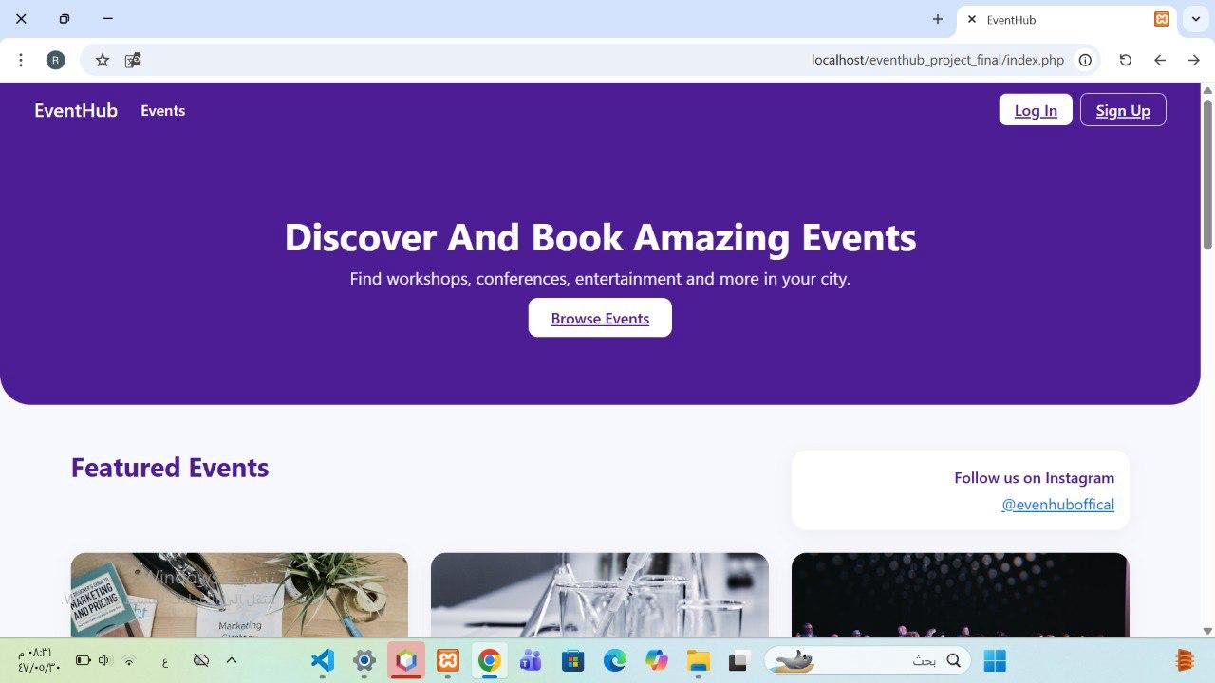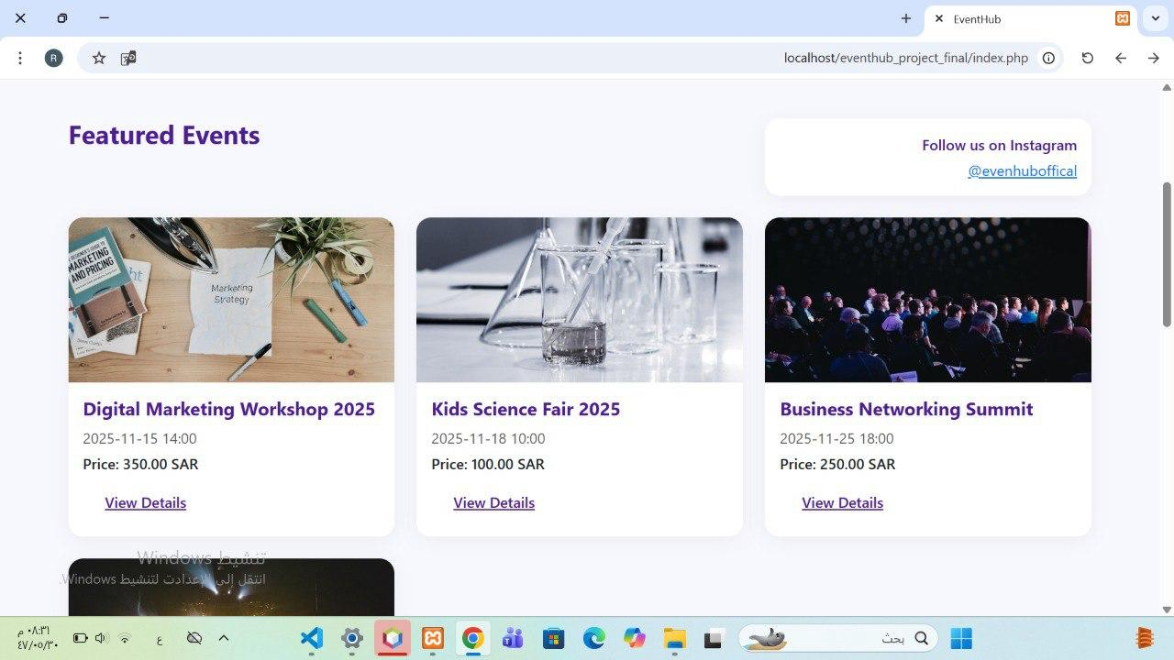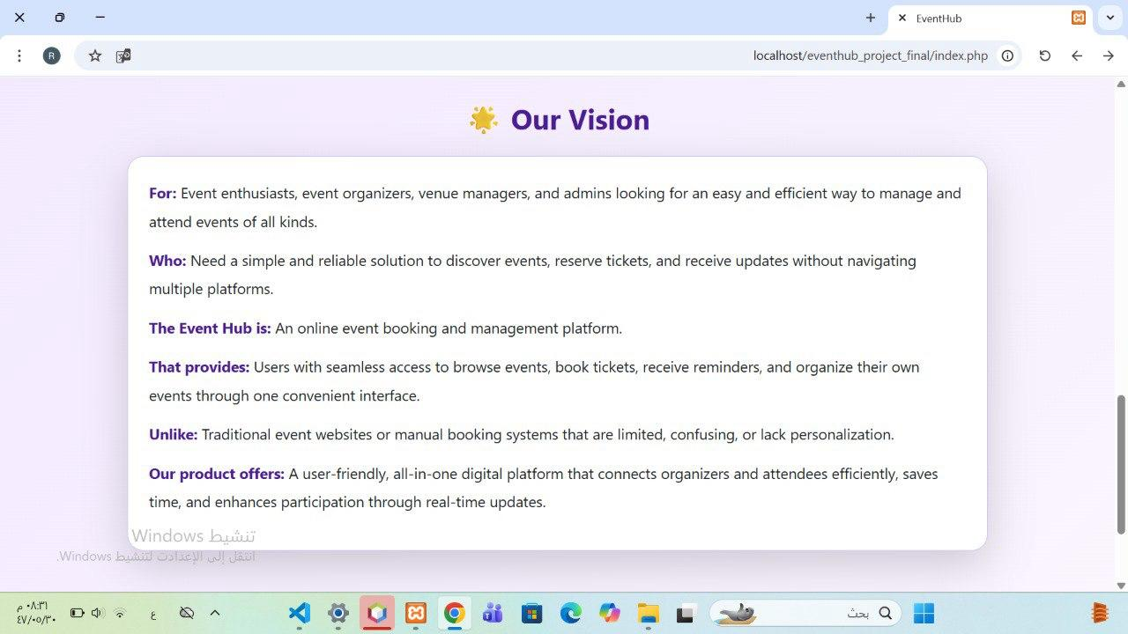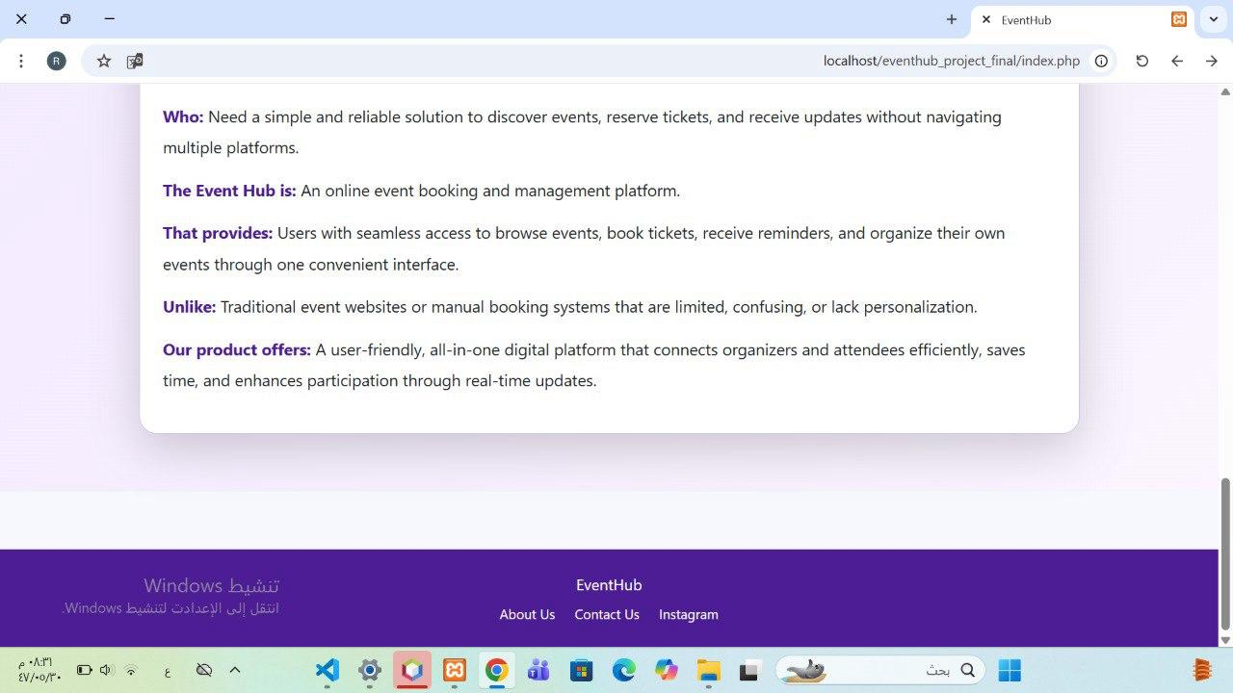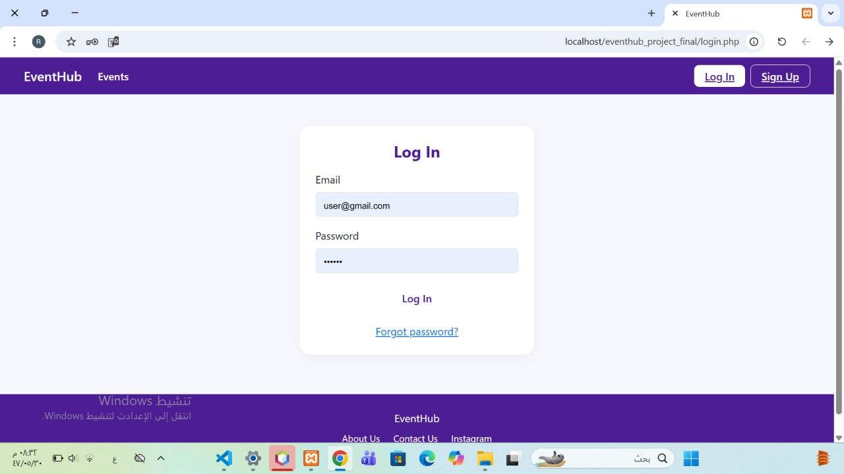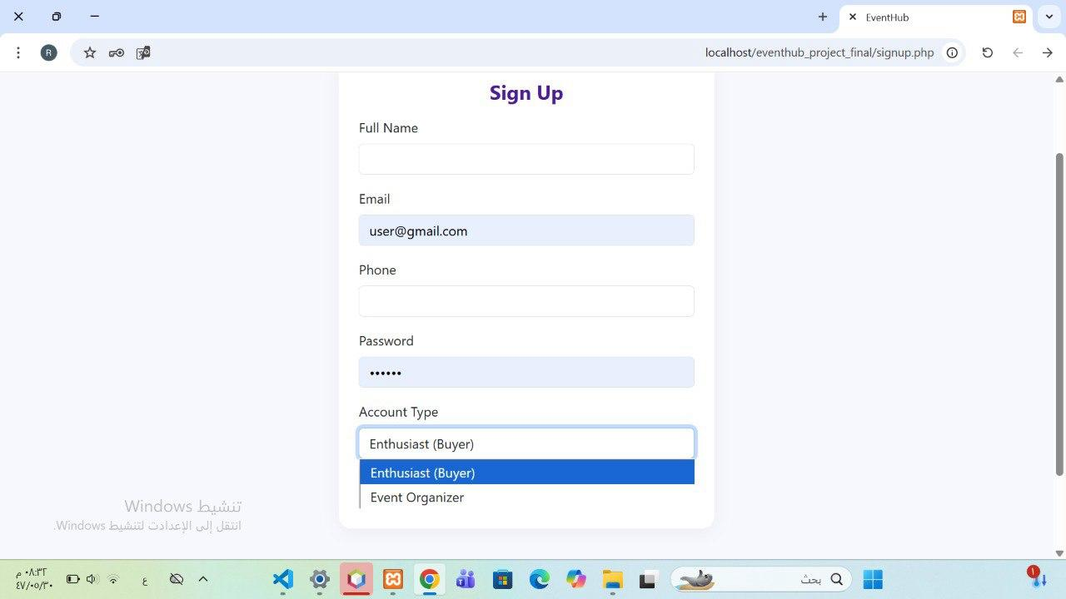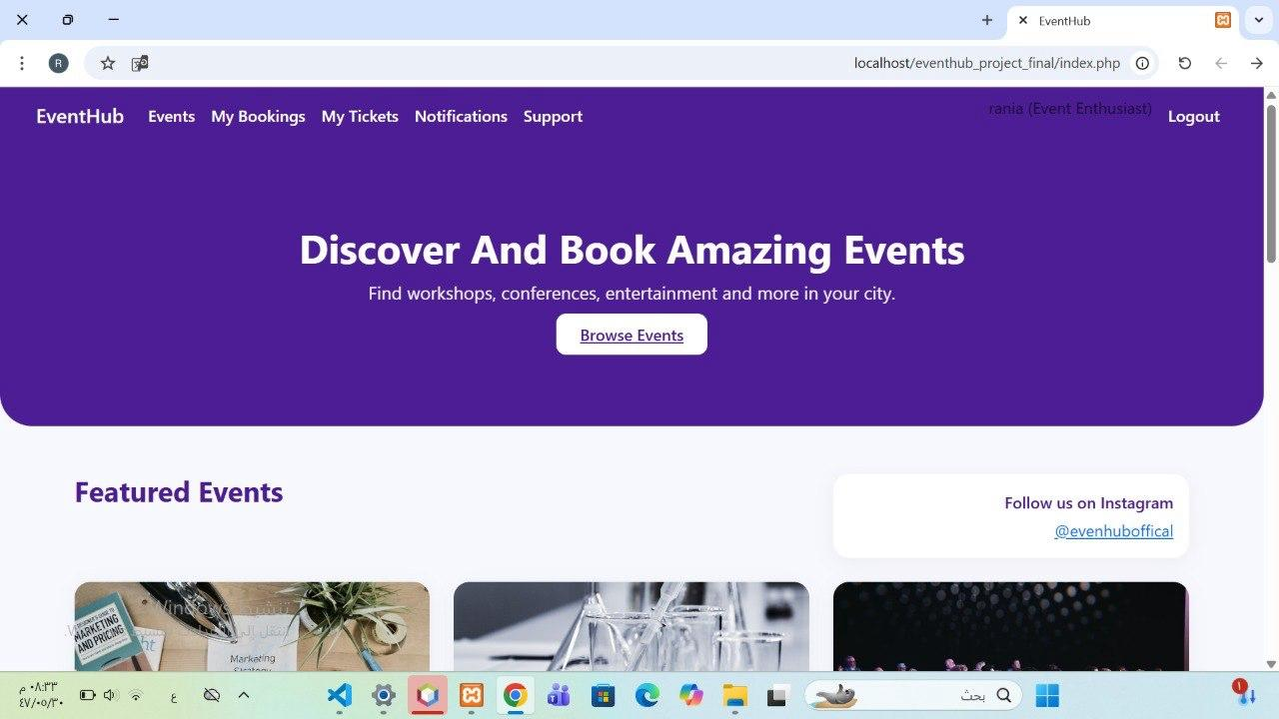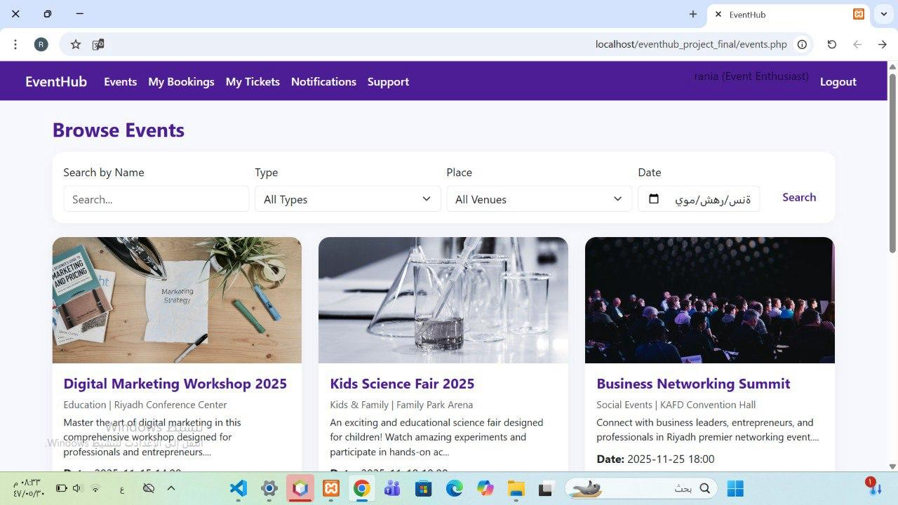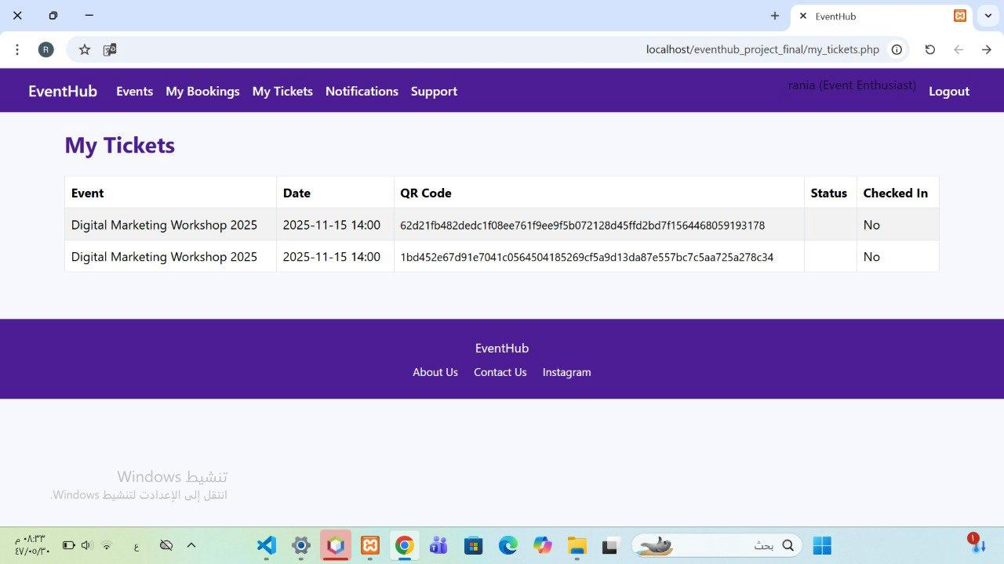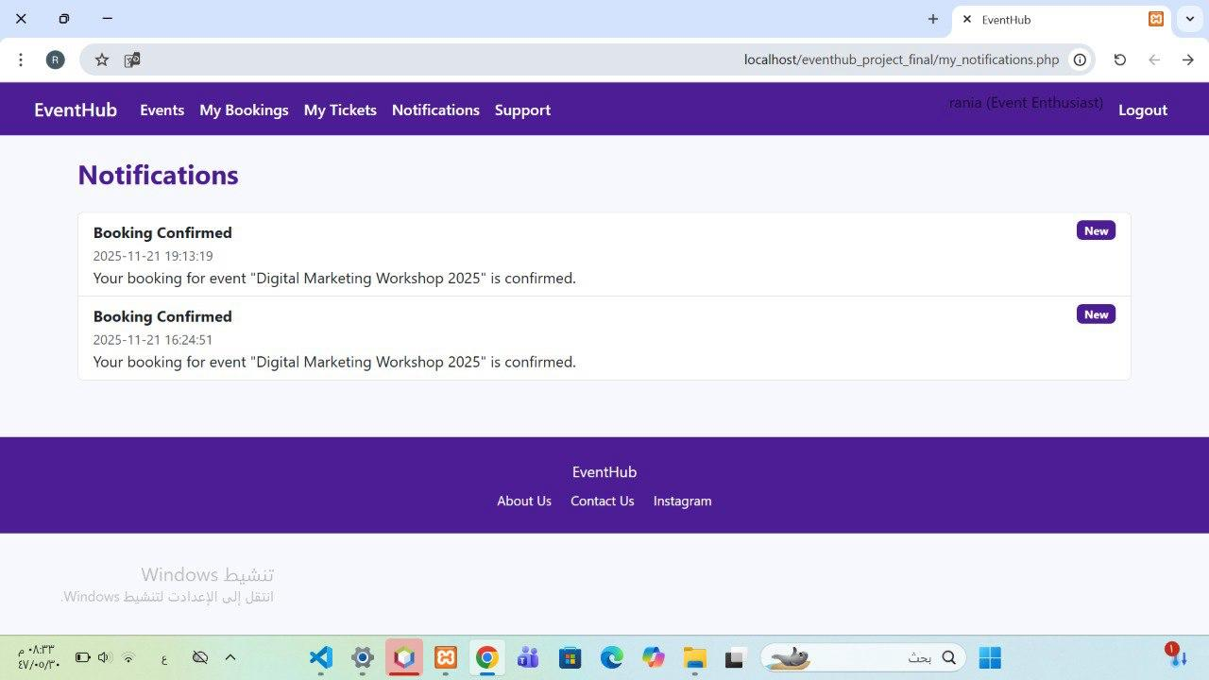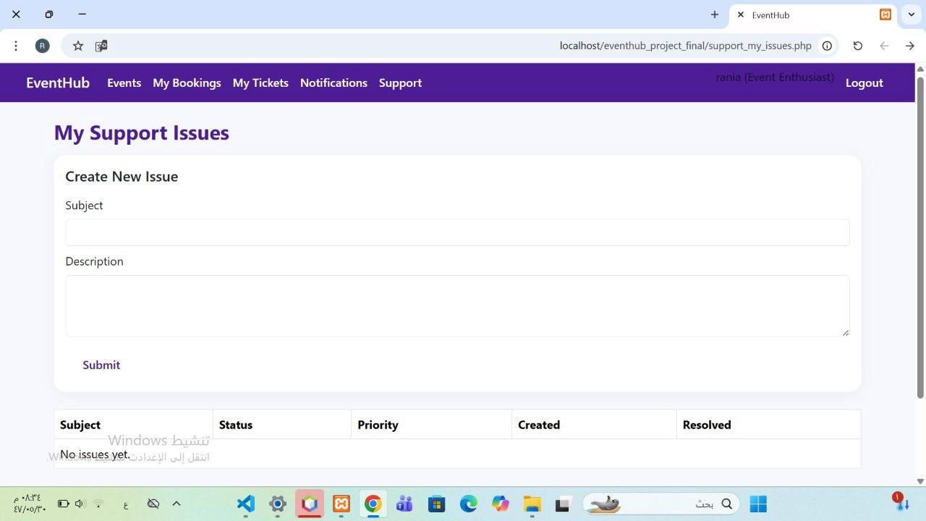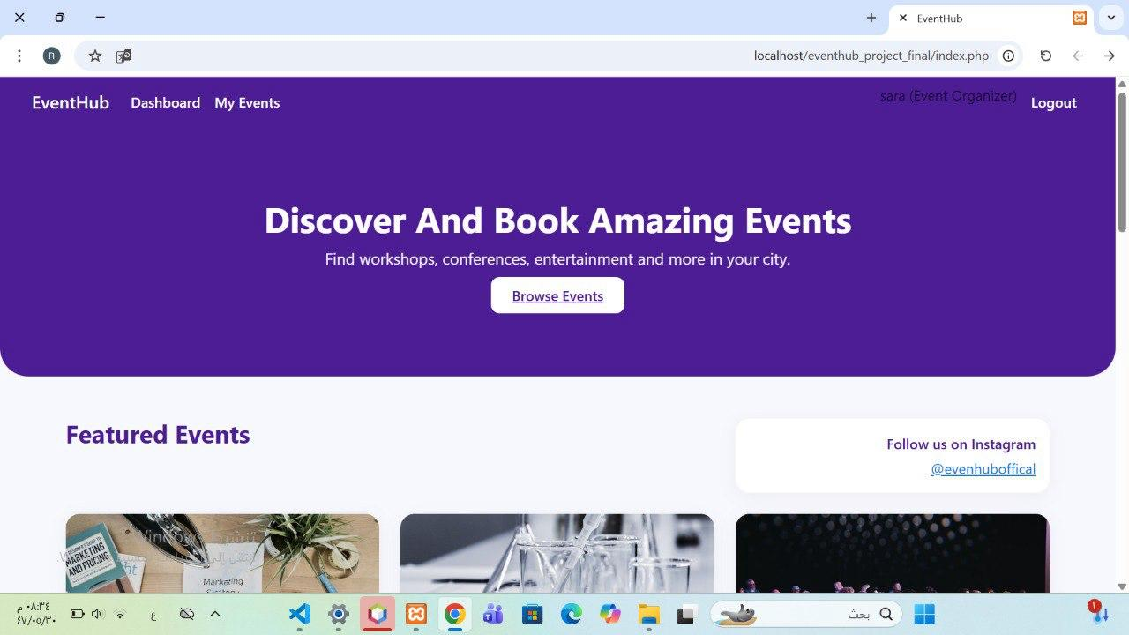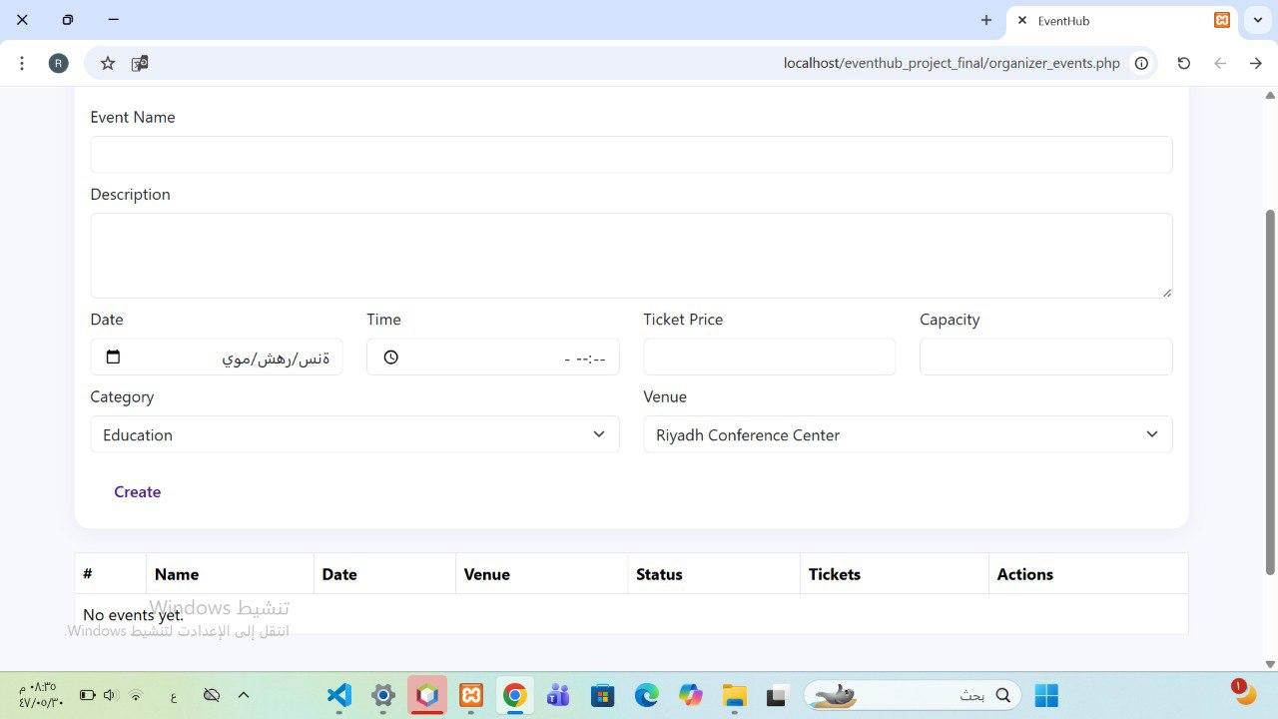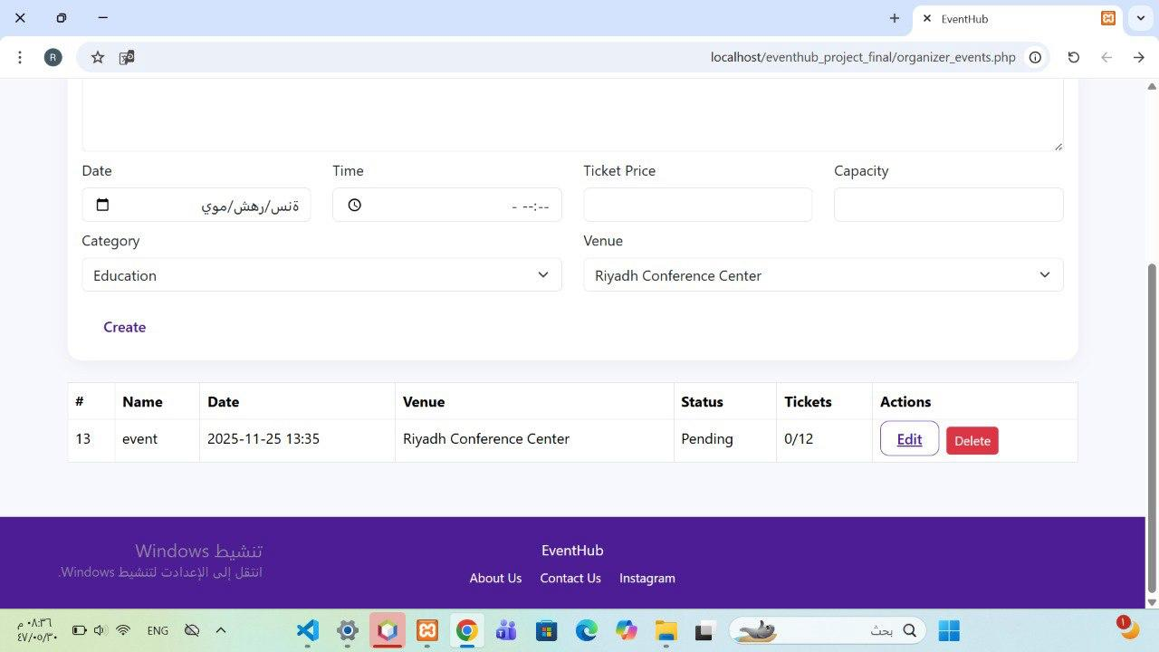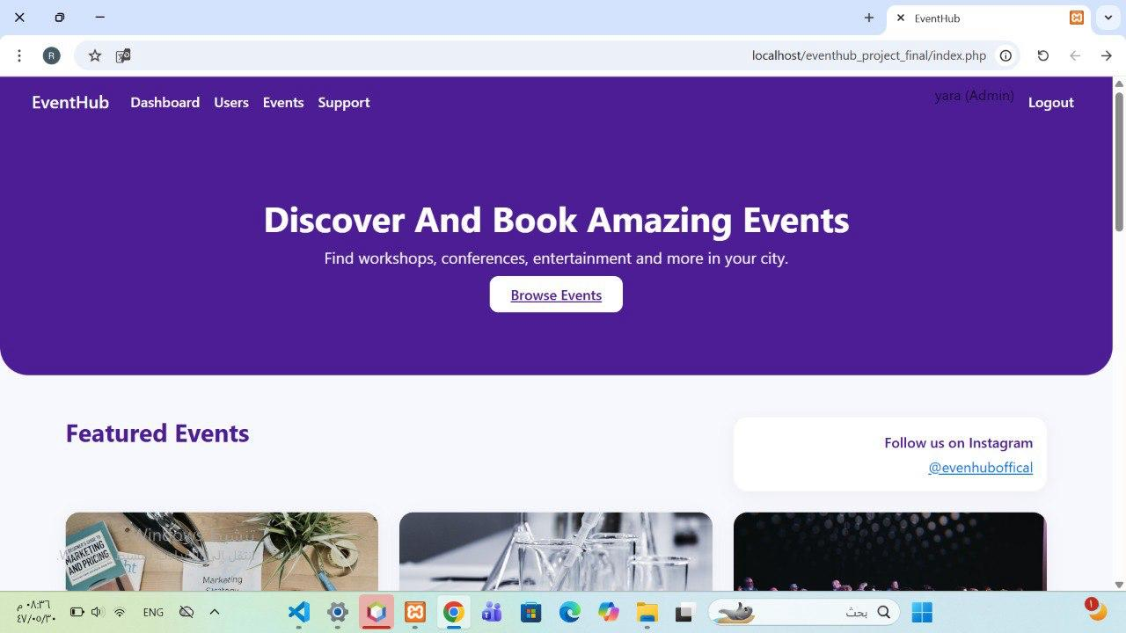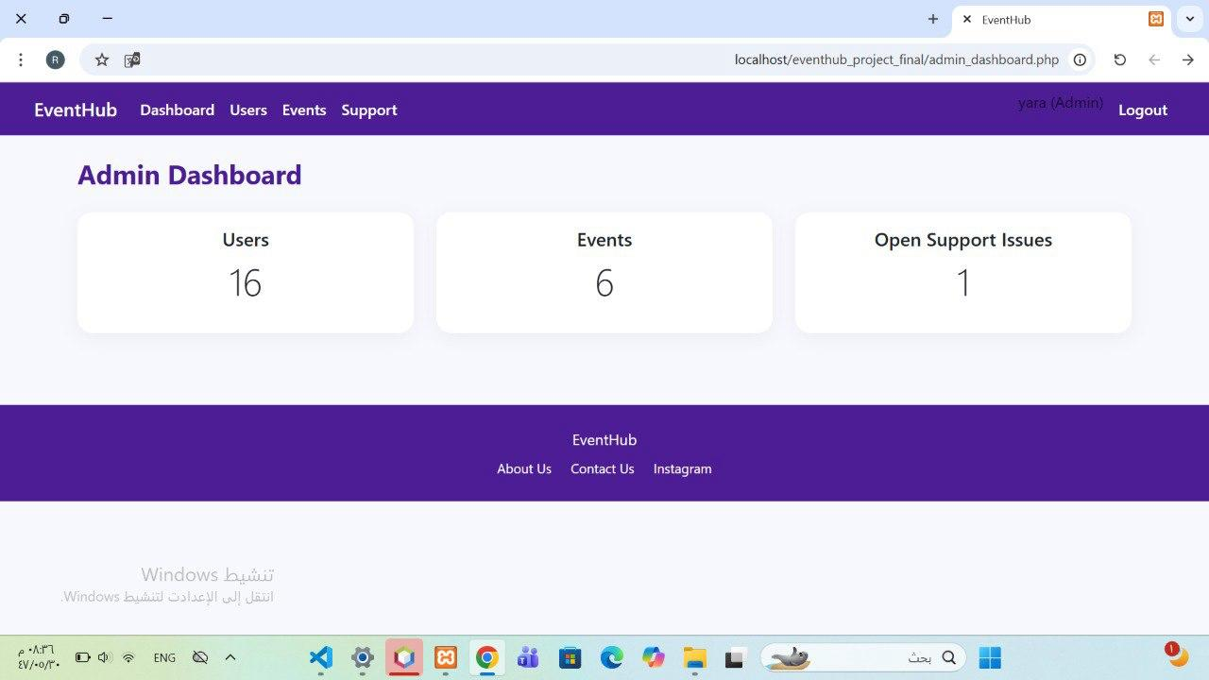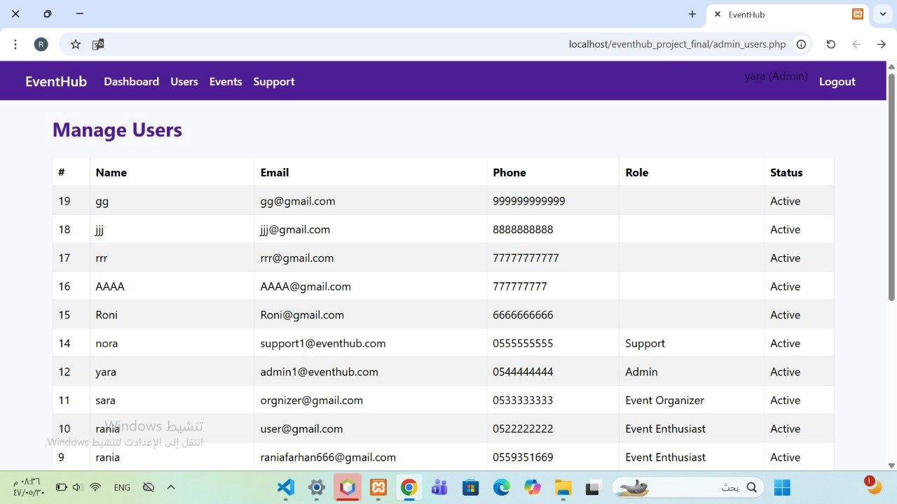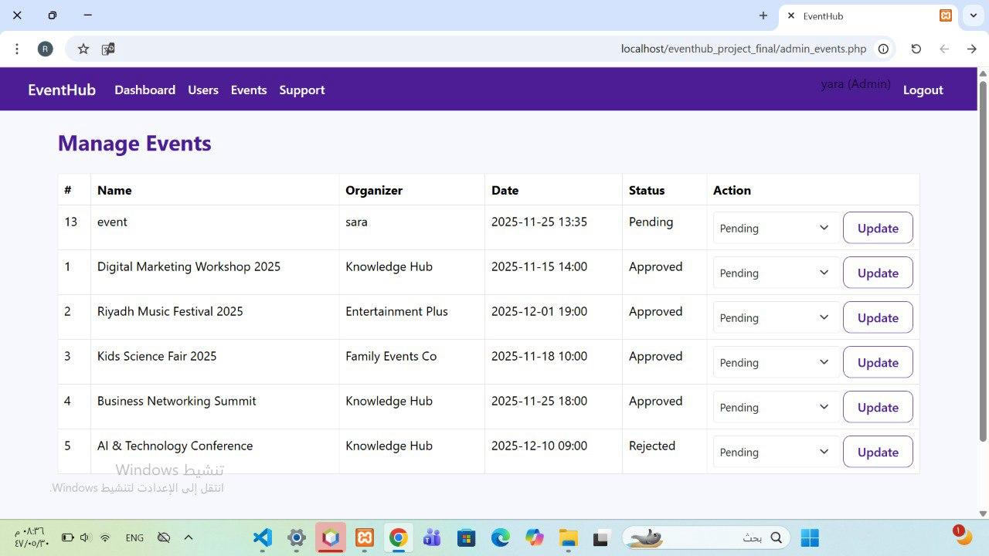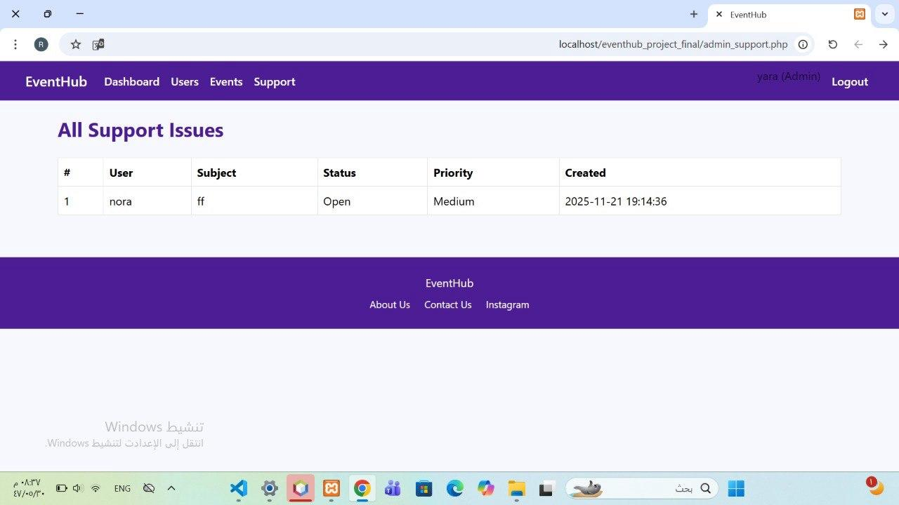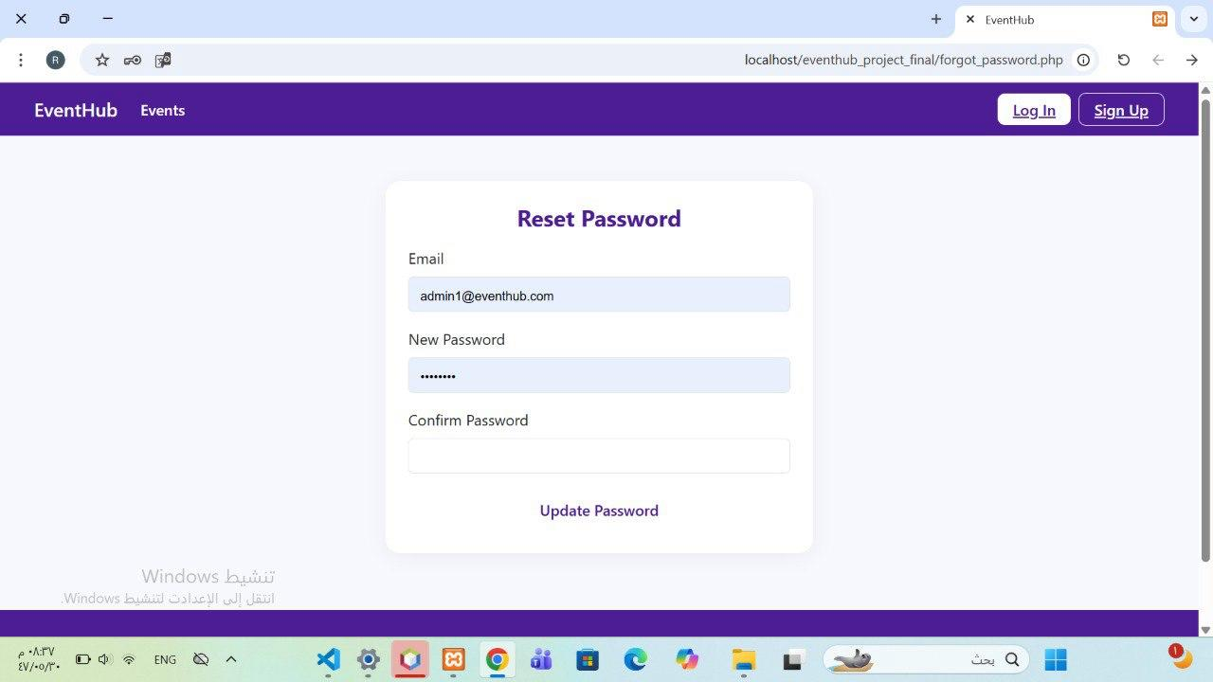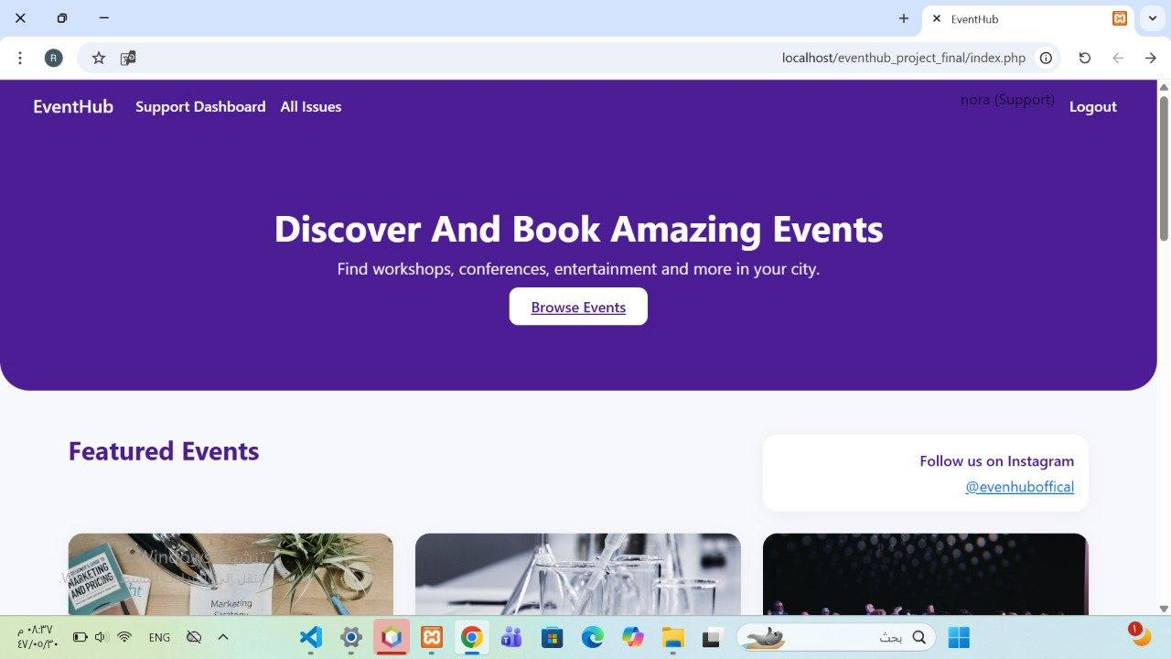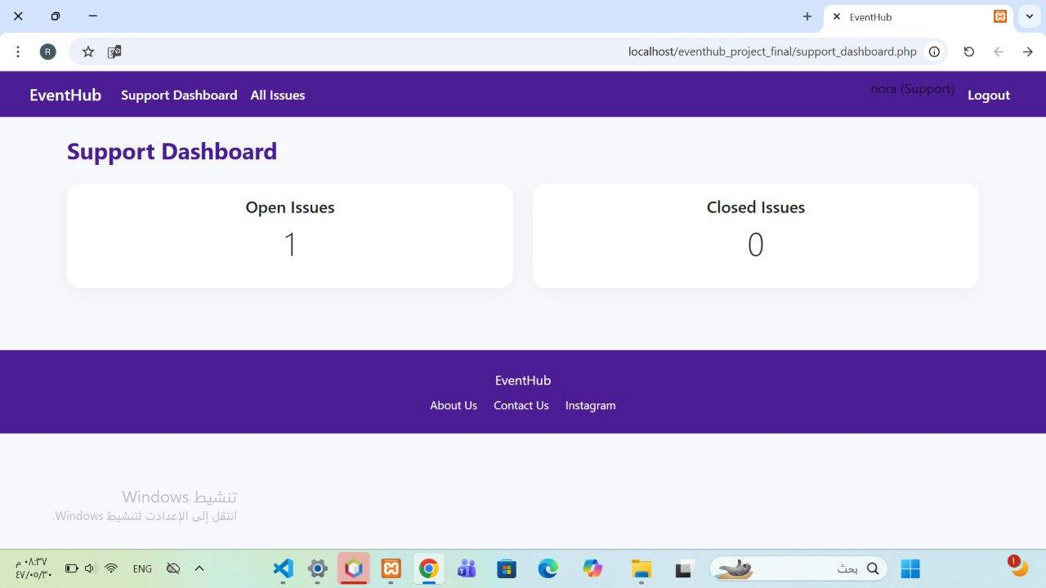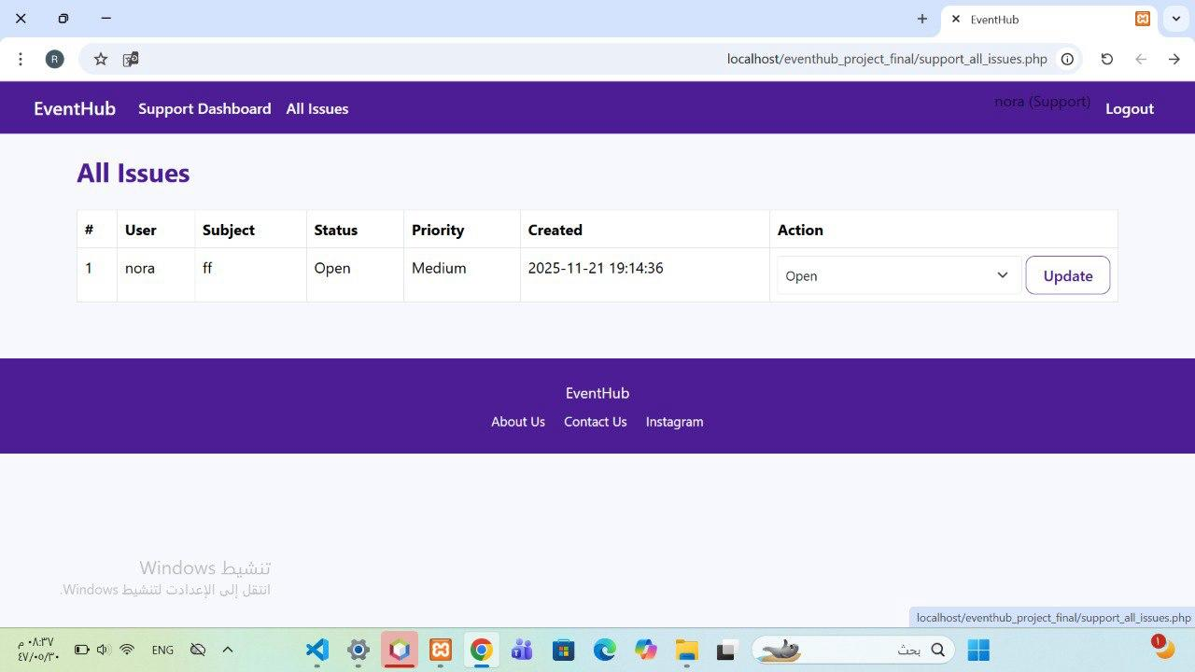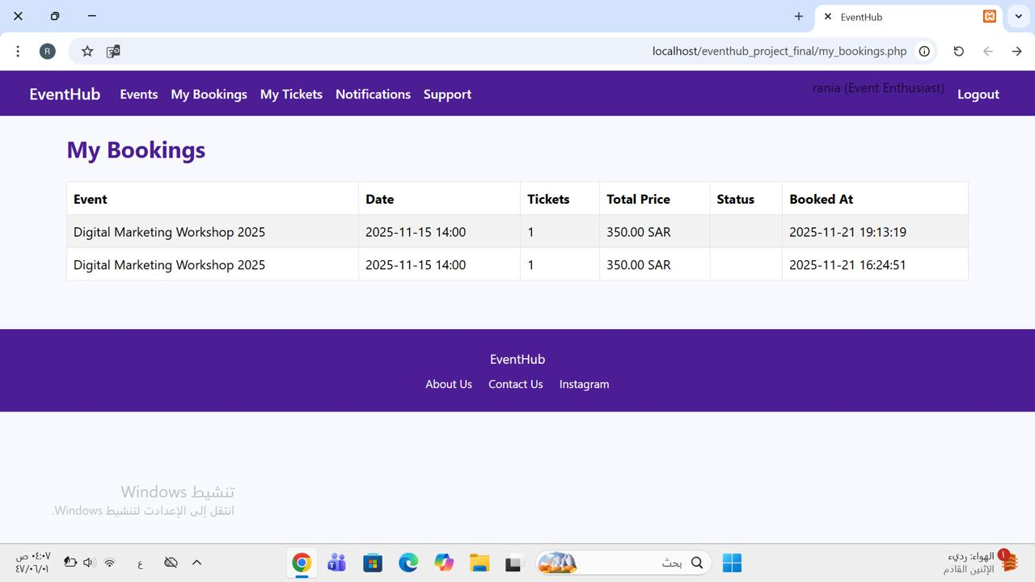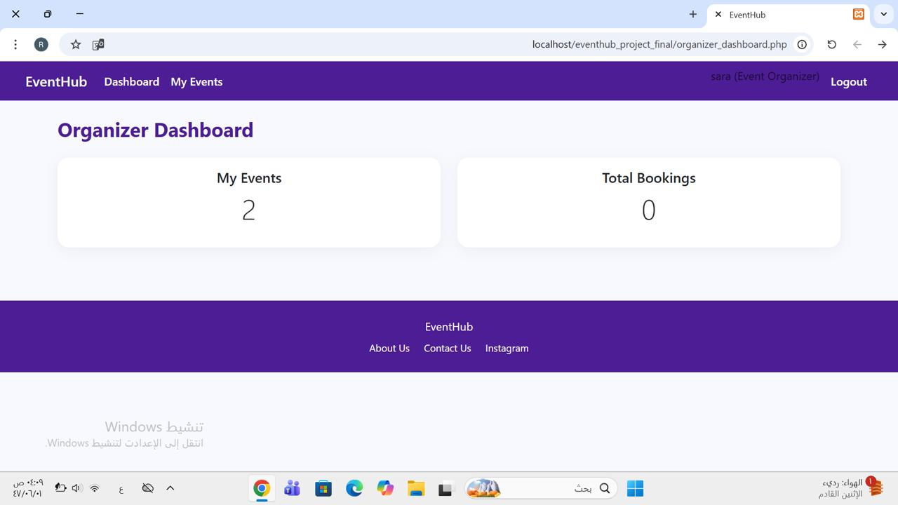

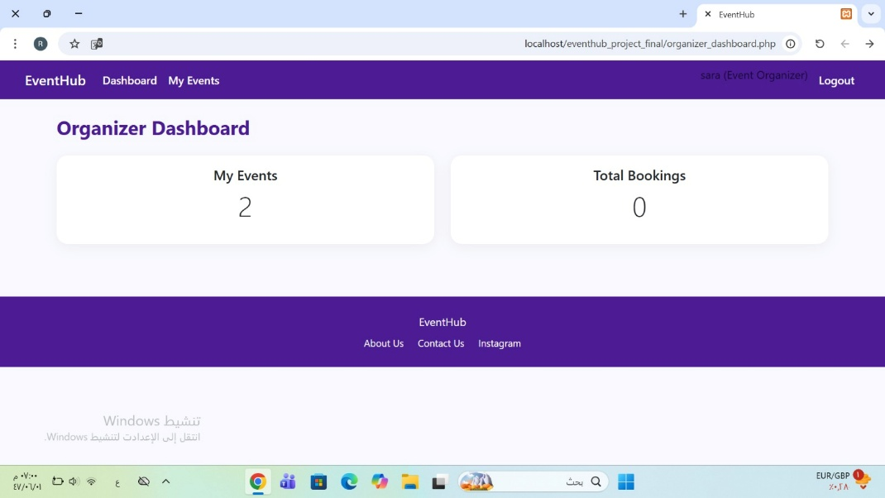

  - Any questions from stakeholders were addressed during the demonstration.
No questions from stakeholders during the demonstration.
- 1.3 Acceptance Criteria Verification:
  - Verification of Acceptance Criteria: All acceptance criteria for the demonstrated items were met. No issues found.
  - II. Product Increment and Stakeholder Feedback:
- 2.1 Product Increment Discussion:
  - Current State of Product Increment: The current product increment achieved the demonstrated product goals and provides value to the customer by enhancing the main functions and providing better user experience in EvenetHub.
  - Alignment with Product Goal: This final increment enhances the main functions of the intended product The features implemented in this sprint is the providing a better user experience in the Event Hub system, supporting our vision to provide an unified and efficient platform for discovering, organizing, and managing events.
  - Value to Users/Customers: the features implemented improve user experience, and Application usability which improves user satisfaction.
- 2.2 Stakeholder Feedback:
  - Key Feedback Received:
Category | Feedback | Explanation
Usability | Some users see that reset password instructions are long. | facilitate it to reduce complains
  - Next Steps Based on Feedback:
Next Step | Description | Related User Story
Shorten reset steps | Make instructions more abstract. | User Story 3
- 2.3 Product Backlog Review:
  - Product Backlog Adjustments: there was some adjustments done.
- Newly Discovered Work: Reducing the number of interfaces for better connection and integration.
one additional user story was added to the backlog:

- User Story 16:
Event Enthusiast, Event Organizer, Admin, Support Team I want to reset my forgotten password so that I can regain access to my account securely.

- User Story 14 was split into two separate stories to align with the INVEST criteria. The original story:
As an Event Organizer, I want to edit or cancel events I created, so that I can update event details or stop registrations when needed.

- After refinement:
- User Story 14.1:
As an Event Organizer, I want to edit my events so I can update event details.
- User Story 14.2:
As an Event Organizer, I want to delete my events so I stop registrations when needed.

III. Progress and Next Sprint Planning:
- 3.1 Progress Toward Product Goal:
  - Contribution to Product Goal: This final increment enhances the main functions of the intended product The features implemented in this sprint is the providing a better user experience in the Event Hub system, supporting our vision to provide an unified and efficient platform for discovering, organizing, and managing events.

- Impediments: The large number of interfaces was an impediment when integrating with the database and connecting the new Sprint 2 components.
- 3.2 Next Sprint Planning Preview:
  - Potential Items for Next Sprint: this is the final sprint.
- 3.3 Action Items:
  - Action Items:
- Product Owner (Shahad) to final review of the Product Backlog.
- UI/UX Designer (Raghad) to do a final UI/UX review.
- Frontend Developer (Layan) to do a final frontend test.
- Backend Developer (Rania) to do a final backend test.
- Scrum Master (Lamyaa) to do a final review to definition of done.

  - IV. Summary and Closing:
- 4.1 Summary of Key Takeaways:
  - Key Takeaways: The sprint released features for better user experience in the Event Hub platform including edit and cancel events, create and display promotional campaigns and password reset.
  - Stakeholder feedback underlines the must to improve usability.
  - The team showed strong progress and communcation with clear goals.

  - Team Accomplishments:
- meet the Sprint Goal.
- Reducing the number of interfaces for better connection and integration.
- showed excellent problem solving and communication throughout development and testing.

- 4.2 Next Steps:
  - Thank You:
Thank you to all participants and stakeholders for their collaboration, time, and feedback during the final sprint.

